1. Use the ping command to test the connectivity to a remote server (e.g., example.com).

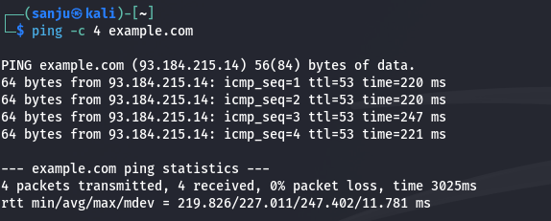

1. Write a script to measure the round-trip time for each packet and analyze the results.

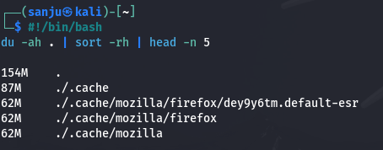

1. Use the traceroute to trace the route packets take to a destination

1. Analyze the output to identify any potential bottlenecks or points of failure in the route.

1. Use the nslookup command to find the IP address of a given domain (e.g., example.com).

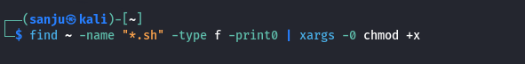

1. Use the netstat command to view active connections and listening ports on your machine.

1. Use the ifconfig (Linux) or ip a command to display network interface configurations.

1. Write a script to report document the configuration of each interface, noting the IP address, subnet mask, and any other relevant information.

1. Perform a basic network scan using nmap on your local network to identify active devices and open ports.

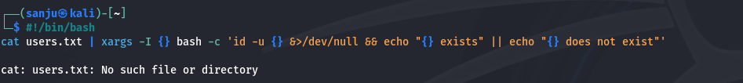

1. Create a report summarizing the devices found, their IP addresses, and the services running on the open ports.

1. Capture network packets using tcpdump on a specific interface.

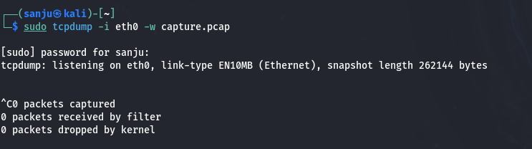

1. Analyze the captured packets for specific protocols (like HTTP or DNS) and summarize your findings.

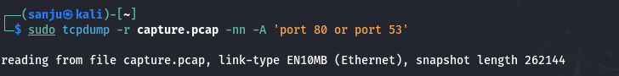

1. Use the whois command to gather registration information about a domain.

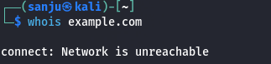

1. Use the hostname command to display and change the hostname of your machine.

1. Use the finger command to gather information about users on a system.

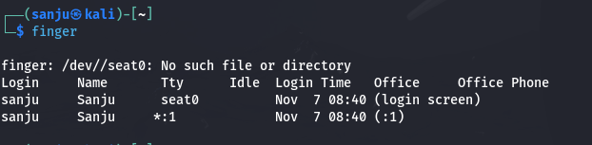

1. Use the who command to see who is currently logged into the system and the last command to view the login history.



